March, 2007

Waldorf Class of 1961

It is that time again when we have a chance to share information about our class.

Much of the information I would like to share with you is already available to you on our class web site. www.waldorclasso61,com

Since our last letter we have learned of two of our classmates having passed away, or as it is reported on our web site they have gone through their “Final Graduation.”
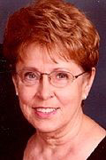
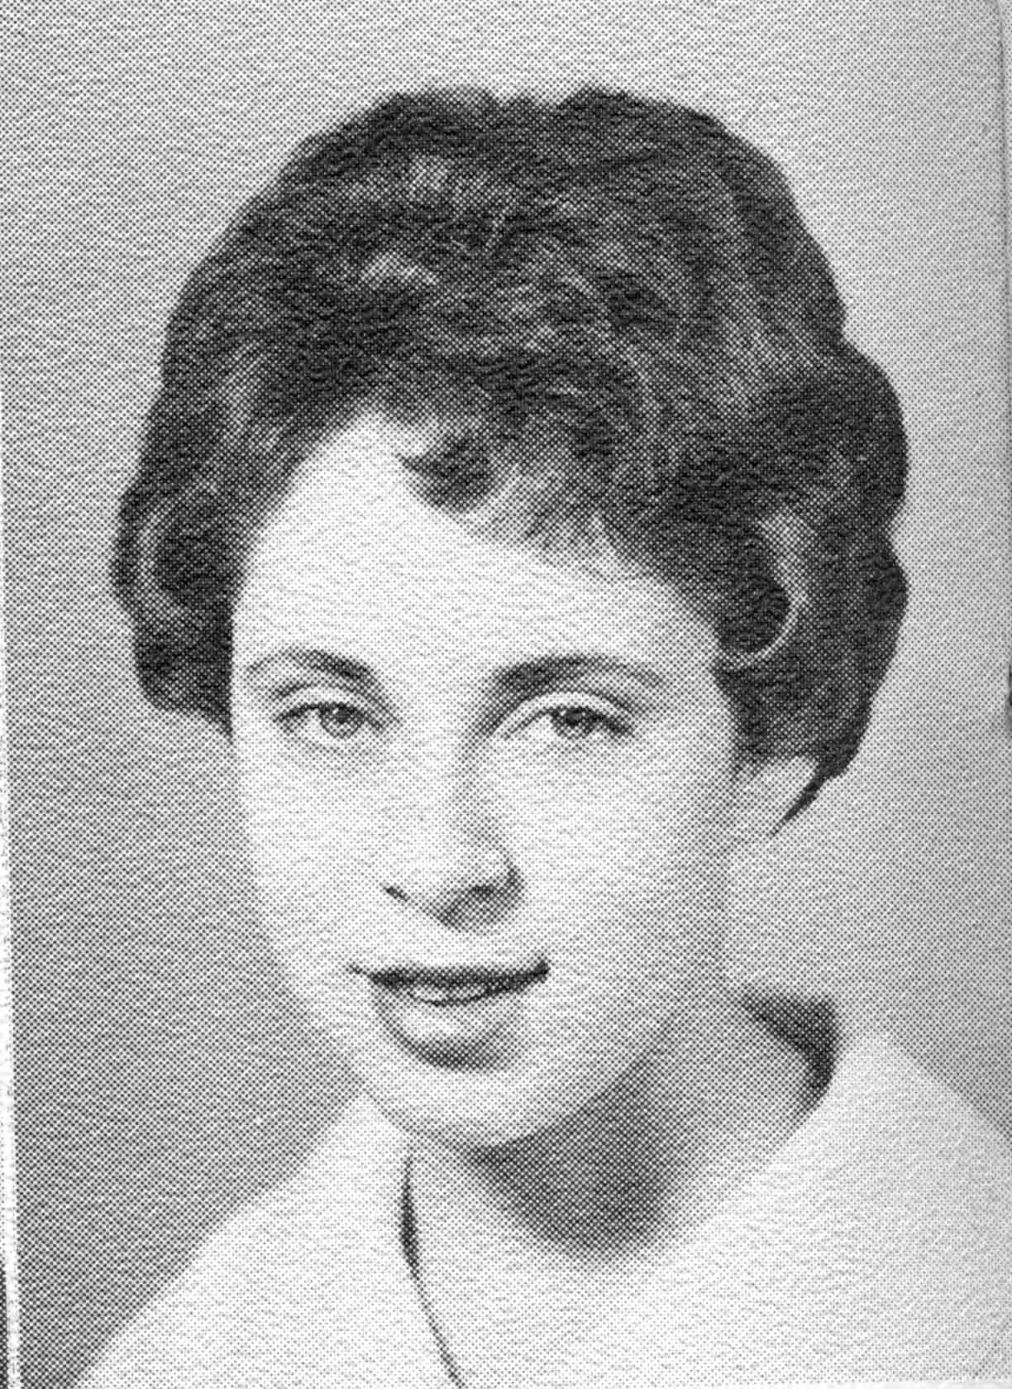
Mary Bakke Lyon, 65, of Zumbrota, died Friday (March 16, 2007) at Saint Marys Hospital in Rochester. Mary Evelyn Bakke was born on May 5, 1941, in Forest City, Iowa. She grew up in Lake Mills, Iowa, and graduated from Lake Mills High School in 1959. She attended Waldorf College and graduated from Luther College in 1963. In the fall of 1963, she started teaching elementary school in Wanamingo. On Dec. 27, 1964, she married Lorin Lyon Jr. in Salem Lutheran Church in Lake Mills, Iowa. The couple made their home in Zumbrota, where she continued her teaching career. She retired from the Zumbrota-Mazeppa School system. She enjoyed sewing, playing piano and raising flowers, especially in her rose garden. She was a member of the church choir, did volunteer reading at several nursing homes and served on the library board.
Survivors include her husband; a son, Marc (Cindy) of Zumbrota; two daughters, Lora (Georg) Wagner of Neillsville, Wis., and Melissa (Brian) Haugen of Zumbrota; three children; and two sisters, Elizabeth Francis and Ellen (Richard) MacGregor. She was preceded in death by her parents and two sisters.
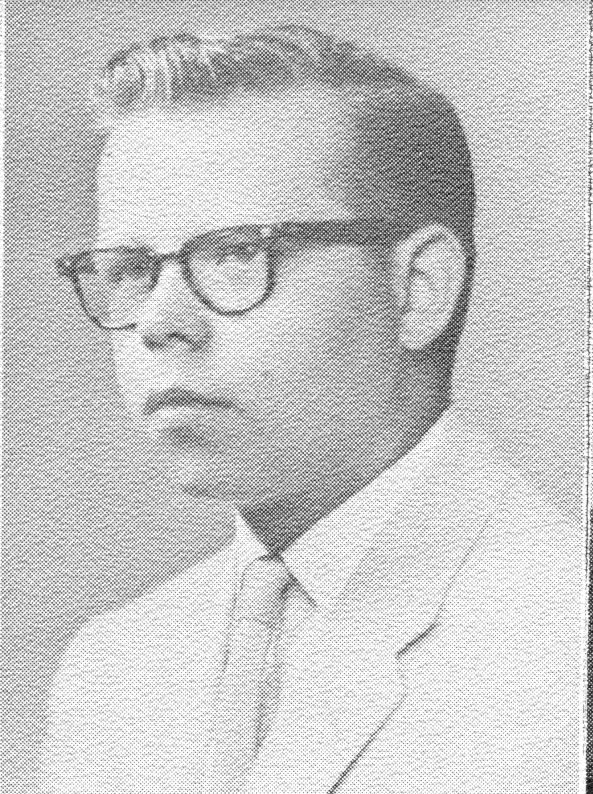
Richard Bruce Holt, 65, of Windom, died Monday, November 27, 2006, at Sioux Valley Hospital, Sioux Falls, S.D.
Born January 27, 1041, in Willmar, he was the son of Joseph and Nora Running Holt.
He received his education in the Wilmar Public Schools, graduating in the Class of 1959. He then attended Waldorf College in Forest City, Iowa, graduating in 1961. He drove truck for Larson Transfer of Bloomington until his retirement in 1998. He also worked part-time for Cenex until becoming ill. He was a member of the Fraternal Order of the Eagles in Windom, where he acted as treasurer. He was also a member of the Window Senior Center, where he served on the board for three years and was the treasurer for one term. He also volunteered for Meals on Wheels.
Surviving are his wife; tow sons, Bruce Holt, Wilmar, and Jeff Holt, Nampa, Idaho; one brother, Gary (Marcia) Holt, Mankato; one sister, Judy (Raymond) Smith; and three grandchildren.
Services were at LaCanne Family Funeral Home, Windom, with Rev. Stephen Norby officiating.

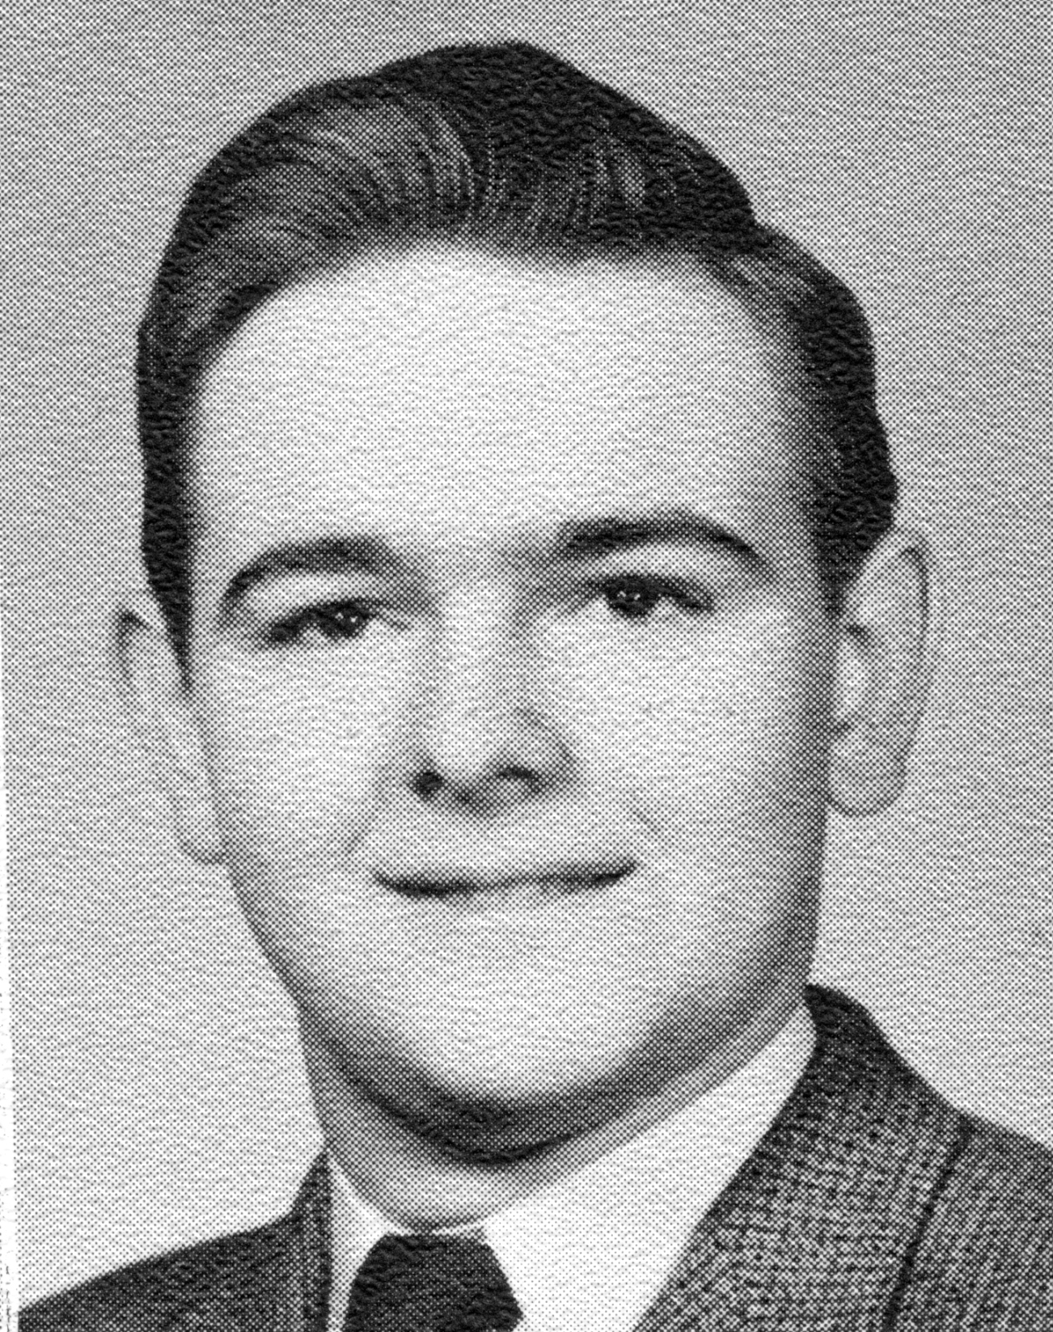
JAMES W. WEISJAHN, age 65 of Waseca died at his home on Tuesday, January 16, 2007.
Born September 5, 1941 in Owatonna, James was the son of William “Bill” and Lola (Briggs) Weisjahn. He attended school in Owatonna and graduated from Medford High School in 1959. He later graduated from Waldorf College in Waverly, IA and Mankato Technical College. On April 16, 1983, Jim was united in marriage to Linda Huber at St. John Lutheran Church in Waseca. He worked at E.F. Johnson Company in Waseca his entire career. Throughout his life, Jim enjoyed fishing, computers, the internet, photography, electronics, model airplanes, listening to his scanner, being a ham radio operator, and was at one time, active with civil defense. He also played the trumpet, and enjoyed bible study with his friends in Medford. Jim was a member of St. John Lutheran Church in Waseca.
Jim is survived by one sister, Sharon Myrick and her husband Ron of Medford; his father and mother-in-law, Lester and Delores Huber of Waseca; his brother and sister-in-law, Larry and LuAnne Huber of Waseca; Nieces and Nephews, Sarah (Steven) Schmidt and their son Aidan, Noël (Grady) Huggett and their children Mickenzie and Hunter, Toni Huber, Tyler Huber, Terry Huber, and Travis Huber and his fiancé Becky Phillops. He was preceded in death by his parents, his wife, and an infant brother.
Funeral services were held on Tuesday, January 23, 2007 at 2:00 PM at St. John Lutheran Church in Waseca with Rev. Vicki Hultine officiating.
Other Class mate news:
Helen Langbehn - " I moved to New Mexico. I'm really enjoying life here. I'm sorry I could not be at the reunion. I just made so many driving trips down here this spring. I had better stay put for a while."
Leonard Dygart - "I wish all my classmates health and happiness in the future. May God Bless all of you."
Donna Miedermair - "Head in the clouds, Feet in the sand, Happy as a clam (at high tide) Living my Dream!"
Janora Gustafson Hodges - "I'm glasd to be sime-retired, prefer to have myself as my boss. Our nine children live in California, Arizona, Iowa, Missouri, Massachusetts and we have 23 grandchildren and 2 great granddaughters. We have been living in Sun city now for 12 years having moved here to work for a hospital. We do live in paradise nine months of the year, but prefer the triple digit temperatures to ice and snow."
Karen Hanna Dyer - " I am so sorry that I could not attend Homecoming this year! Thery are always so much fun and it's alsways great to see classmats from '61. We signed up for a trip last spring, so we are on our way to New York, Boston and the East on Septermber 23. I will look forward for your pictures in the newsletter. God Bless!"
Solveig Hyland Carlson - "Discerning where we'll live after George's term as Bishop ends, July 2007. So no new grandchildren. Hannah is nearly 13 years and Noble is 11 years. Erik and Amy both have "significant others." George and I celebrated our 41st wedding anniversary at Fanny Hill Dinner Theatre, Eau Claire; say the play "SEE HOW THEY RUN" with memories of our meeting (Hancock County, Garner) September 1964 in same play as leads. Fun."
Darel Swenson - "I have practiced law for 31+ years, taught law for 30 years, served as a counciliation court judge in Hennepin count, Minnesota, since 1979. I have procticed before the United States Supreme court, the Eighth Circuit federal court of appeals, the federal district court in Minnesota and the district, appeals, and supreme courts in Minnesota. In addition. I have practiced in several states other than in Minnesota. My career has been rich and rewarding. I am thankful to Waldorf for its having given me the educational start that I needed in 1059."
Katherine Toft Nielsen - "Both Ron and I have retired this year and with thakfulness for good halth and family. Ron completed more than 30 years as a parish pastor, Bible Camp executive and as an interim pastor. My 30+ years were primarly as an EBN teacher with adolescents. We recently spent a year serving the church in Madagascar. We appreciate the 2 years we spent at Waldorf."
Jean Kropf Drethe - "I am retired and live in chandler, AZ."
Janet Hetland Hernes - "We retired in Forest City in November 2003. Our children live in Canton, Sd, Portland, OR and Forest City, IA. We have 3 granddaughters in Canton, SD and a grandchild expected here in Forest city in October."
Carolyn Larson Price - "After receiving my Masters in community counseling, I was executive director of Parents United in Mason City, a non-profit agency that provided counseling for families with incest issues. Two years ago I opened Elderberry Inn Bed and Breakfast in Forest City."
Jon Rorem - The newest event in our "retirement" lives is the starting of a new company called CareGifting.
We invite you to visit our site at www.caregifting.com.
I apologize for this getting so long, but there was a lot of information to share at this writing.
I encourage many of you who have not yet provided us with your E-mail address to let us know what it is so you can be added to our mailing list. We have the ability to share information with those of us on the list by sending mail to just one address. It is a secure service, only addresses added to the list are able to get information and only addresses on the list are able to mail to it. But I need your address to add it to the service.
I had asked on our mailing list for ideas to add to our Web site, I received a couple ideas:
Dan...if you're doing a collage for the page, I think Richard Moen's black Renault Dauphine on the front porch of Salveson during the winter should definitely be included (but then, I like the wryer side of our Waldorf experience). But seriously, I do think that some of those things we knew (the Annex, the old Music Hall, for instance) should be included in our web page.Erik Tingberg
So if anyone has pictures like Erik mentioned, send me copies and we can put them on our site.
There must be a picture of Dr. Tanner there some place - that's essential
from my point of view. - Jon Rorem
So if anyone has pictures of Dr. Tanner, especially with students, send it my way and we will see that it gets on the site.
Any other ideas for changes or additions to the site are welcome. Take a look and send me your ideas. dan@boku.net
I hope and pray that this finds you healthy and enjoying life. It was great getting together with some of our class at the reunion, but hope for more chances to get together. At times it seems like a lifetime since our two years at Waldorf and at other times it seems as yesterday. Life passes so fast. So if you can share your experiences with us I will see that they are either added to our Web site or for sure added to our next letter.
Also take some time to visit the Waldorf Web site, do it often and see the great things happening there. www.waldorf.edu, and be sure to sign up for the Waldorf Alumni E-Newsletter.
At this time Brad and Janet Anderson will be matching all new and increased gifts dollar for dollar up to $500,000. if received before May 31, 2007. Brad is a Waldorf grad from the class of “69.
Peace and Love,
Dan Eisch

